FEMA Logo

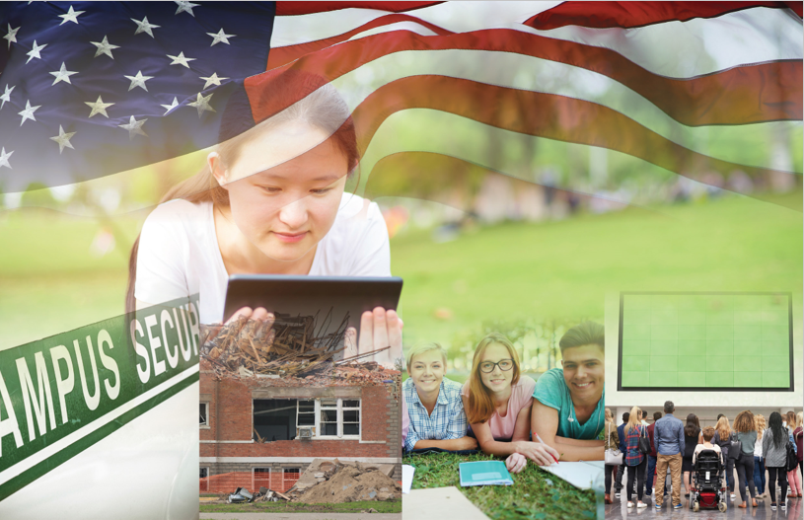

*Campus Resilience Program*

*Exercise Starter Kit*

**Tornado Tabletop Exercise**

Situation Manual

[Insert Date]

**Sponsor Logo**

# Handling Instructions

[**Planner Note:** The purpose of this Situation Manual is to provide a baseline exercise document that institutions of higher education can use to assess their emergency plans, policies, and procedures. The sample content contained in this document can be tailored as necessary to meet the desired goals and outcomes for the exercise by filling in all bracketed content that is highlighted in red. This document is to be used in tandem with the Tornado Tabletop Exercise Conduct Briefing and Facilitator Guide, therefore any changes made to this document will also need to be aligned with those documents.]

The title of this document is the *Tornado Tabletop Exercise (TTX) Situation Manual*. This document should be safeguarded, handled, transmitted, and stored in accordance with appropriate security directives. Reproduction of this document, in whole or in part, is prohibited without prior approval from the exercise planning team. This document has been marked as “FOR DISCUSSION PURPOSES ONLY.”

For more information on this exercise, please consult the following point of contact:

**[Lead Planner Name]**

[Position]

[Organization]

[Division within Organization]

[Phone]

[Email]

# Table of Contents

1. Handling Instructions i
2. Table of Contents ii
3. Agenda 1
4. Overview 2
5. General Information 3

Introduction 3

Overview 3

Objectives and Core Capabilities 3

1. Participant Information and Guidance 4

Participant Roles and Responsibilities 4

Exercise Structure 4

Exercise Guidelines 5

Assumptions and Artificialities 5

1. Module 1: Preparedness 6

Scenario (5 Days Out – 1 Day Out) 6

Discussion Questions 6

1. Module 2: Response 9

Scenario (20 Minutes – 48 Hours) 9

Discussion Questions 9

1. Module 3: Recovery 12

Scenario (48 Hours – 96 Hours) 12

Discussion Questions 12

1. Appendix A: Relevant Plans A-1
2. Appendix B: Participating Organizations B-1
3. Appendix C: Acronyms C-1
4. Appendix D: Glossary D-1

# Agenda

**Tornado Tabletop Exercise**

**[Date]; [Time]**

**[Location of Exercise]**

[**Planner Note:** The agenda items and times listed below are general suggestions for the exercise breakdown. Activities and times may be adjusted based on an institution’s exercise scope, planned attendance, and duration.]

|  |  |
| --- | --- |
| [00:00 a.m.] | **[Welcome and Introductions] [Recommended Time: 5 Minutes]** |
| [00:00 a.m.] | **[Exercise Overview] [Recommended Time: 10 Minutes]** |
| [00:00 a.m.] | **Module 1: Preparedness [Recommended Time: 60 Minutes]** |
| [00:00 a.m.] | **Break [Recommended Time: 10 Minutes]** |
| [00:00 p.m.] | **Module 2: Response [Recommended Time: 60 Minutes]** |
| [00:00 a.m.] | **Break [Recommended Time: 10 Minutes]** |
| [00:00 p.m.] | **Module 3: Recovery [Recommended Time: 60 Minutes]** |
| [00:00 p.m.] | **Break [Recommended Time: 10 Minutes]** |

# Overview

|  |  |
| --- | --- |
| **Exercise Name** | Tornado Tabletop Exercise |
| **Exercise Date** | [Insert Date]; [Insert Start Time – End Time] |
| **Scope** | This exercise is a discussion-based tabletop exercise, planned for [insert exercise duration] at [insert exercise location]. Divided into three Modules, this exercise will examine tornado preparedness, response, and recovery operations. |
| **Mission Areas** | Preparedness, Response, and Recovery |
| **Objectives** | 1. **Operational Coordination:** Assess the ability to establish and standardize protocols for integrating whole community partners into a unified and coordinated operational structure during planning, response, and recovery efforts 2. **Physical Protective Measures:** Implement and maintain risk-informed countermeasures and policies protecting people, borders, structures, materials, products, and systems associated with key operational activities and acritical infrastructure sectors 3. **Health and Social Services:** Mass Care Services: Examine strategies to provide, restore, and improve life-sustaining health, human, and social services within affected populations following a disaster 4. **Public Information and Warning:** Review the processes related to disseminating time-critical, operational, and incident-related intelligence and information to the whole community 5. **Infrastructure Systems:** Stabilize critical infrastructure functions, minimize health and safety threats, and efficiently restore and revitalize systems and services to support a viable, resilient community |
| **Scenario** | The exercise scenario will include an EF3 tornado resulting in injuries, fatalities, and considerable damage to the [insert your institution’s name] campus. |
| **Participating Groups/Departments** | * [Insert Participating Organization]   + [Insert Participating Sub-Organization] * [Insert Participating Organization]   + [Insert Participating Sub-Organization]   A full list of participating organizations is provided in **Appendix B.** |
| **Sponsoring Organization** | [Insert Sponsoring Organization(s)] |
| **Point of Contact** | [Insert Point of Contact Name], [Position], [Organization]  [Phone number], [Email] |

# General Information

## Introduction

This document serves as the Tornado Tabletop Exercise Situation Manual (SitMan). It includes the exercise goals and objectives, scenario details, as well as discussion questions for use during the exercise. In addition to aligning with the National Preparedness Goal, the content contained in this SitMan has been designed in accordance with Homeland Security Exercise and Evaluation Program (HSEEP) doctrine.

## Overview

The U.S. Department of Homeland Security (DHS), Office of Academic Engagement (OAE) is pleased to support the Tornado Tabletop Exercise as part of the broader Campus Resilience (CR) Program Exercise Starter Kits. This Exercise Starter Kit was made possible through collaboration and coordination with the Federal Emergency Management Agency (FEMA) National Exercise Division (NED).

The broader purpose of each Exercise Starter Kit offered through the CR Program is to support practitioners and senior leaders from the academic community in assessing emergency plans, policies, and procedures while also enhancing overall campus resilience. Specifically, this Exercise Starter Kit will provide the opportunity to examine preparedness, response, and recovery operations related to a tornado.

## Objectives and Core Capabilities

The following objectives in **Table 1** describe the expected outcomes for this exercise. The objectives are linked to core capabilities, which are distinct critical elements necessary to achieve the specific mission area(s).

Table 1: Exercise Objectives and Core Capabilities

|  |  |
| --- | --- |
| Exercise Objective | Core Capability |
| 1. Assess the ability to establish and standardize protocols for integrating whole community partners into a unified and coordinated operational structure during planning, response, and recovery efforts. | * Operational Coordination |
| 1. Implement and maintain risk-informed countermeasures and policies protecting people, borders, structures, materials, products, and systems associated with key operational activities and acritical infrastructure sectors. | * Physical Protective Measures |
| 1. Examine strategies to provide, restore, and improve life-sustaining health, human, and social services within affected populations following a disaster. | * Health and Social Services; Mass Care Services |
| 1. Review the processes related to disseminating time-critical, operational, and incident-related intelligence and information to the whole community. | * Public Information and Warning |
| 1. Stabilize critical infrastructure functions, minimize health and safety threats, and efficiently restore and revitalize systems and services to support a viable, resilient community. | * Infrastructure Systems |

# Participant Information and Guidance

## Participant Roles and Responsibilities

The term *participant* encompasses many groups of people, not just those playing in the exercise. Groups of participants involved in the exercise, and their respective roles and responsibilities, are detailed below.

### Facilitator(s)

The Facilitator will guide exercise play and is responsible for ensuring that participant discussions remain focused on the exercise objectives. They provide additional information and resolve questions as required. They are also responsible for making sure everyone is included in the conversation and has the opportunity to participate.

### Players

Players have an active role in discussing their preparedness, response, and recovery activities during the exercise. Players should discuss or initiate actions based on the simulated exercise scenario.

### Observers

Observers may visit or view selected segments of the exercise but do not actively engage in exercise discussions.

### Support Staff

The exercise support staff includes individuals who perform administrative and logistical support tasks during the exercise (e.g., registration, catering, etc.).

## Exercise Structure

The Tornado Tabletop Exercise will consist of three [insert duration]-minute Modules that focus on preparedness, response, and recovery operations. Each Module will consist of two separate activities: a scenario overview and facilitated discussions. The exercise facilitator will first provide an overview of the scenario and will then engage participants in facilitated discussions around a set of questions. Discussions should focus on key actions, activities, and decisions that each player would perform given the specific scenario conditions. The three exercise Modules include:

* **Module 1** will examine tornado preparedness efforts
* **Module 2** will examine response efforts in the aftermath of an EF3 tornado
* **Module 3** will examine short-term recovery options following an EF3 tornado

The approximate duration of each exercise activity is noted in **Table 2** below.

[**Planner Note:** The timing of the items in Table 2 are general suggestions. Activities and times may be adjusted based on an institution’s exercise scope, planned attendance, and duration.]

Table 2: Module Structure

|  |  |  |  |
| --- | --- | --- | --- |
|  | Module 1 | Module 2 | Module 3 |
| **Total Minutes** | **[60 Minutes]** | **[60 Minutes]** | **[60 Minutes]** |
| **Scenario Updates** | **[5 Minutes]** | **[5 Minutes]** | **[5 Minutes]** |
| **Facilitated Discussions** | **[55 Minutes]** | **[55 Minutes]** | **[55 Minutes]** |

## Exercise Guidelines

This exercise will incorporate a scenario-based format guided by the event objectives. The Modules and associated discussion questions support achievement of the objectives by initiating discussions, facilitating decision-making, and assisting participants in the arrival of appropriate response outcomes. This approach allows the discussions to focus on situations within a moving timeline and for participants to contribute to the discussion from the perspective of their role in the scenario. The Facilitator will ensure that the scenario moves along at an appropriate pace and that all participants have an opportunity to contribute.

## Assumptions and Artificialities

### Assumptions

Assumptions are the implied factual foundation for the exercise and are assumed to be present before the exercise starts. The following assumptions apply to the exercise:

* Exercise players will use existing plans, policies, procedures, and resources to guide responses
* Participants may need to balance exercise play with real-world emergencies; real-world emergencies take priority
* [Insert any additional assumptions that may be relevant to the exercise]

### Artificialities

During this exercise, the following artificialities apply:

* The scenario is plausible, and events occur as they are presented
* There is no “hidden agenda” nor are there any trick questions
* The scenario assumes certain player actions as it moves through each phase; players should first discuss the actions stipulated by the scenario
* Players are welcome to engage in “what if” discussions of alternative scenario conditions
* [Insert any additional artificialities that may be relevant to the exercise]

# Module 1: Preparedness

## Scenario (5 Days Out – 1 Day Out)

**[Insert Date and Time]**

A large system of severe thunderstorms begins moving into your area. The National Weather Service (NWS) reports that the conditions are favorable for the development of tornados.

Figure 1: Funnel Cloud Forms

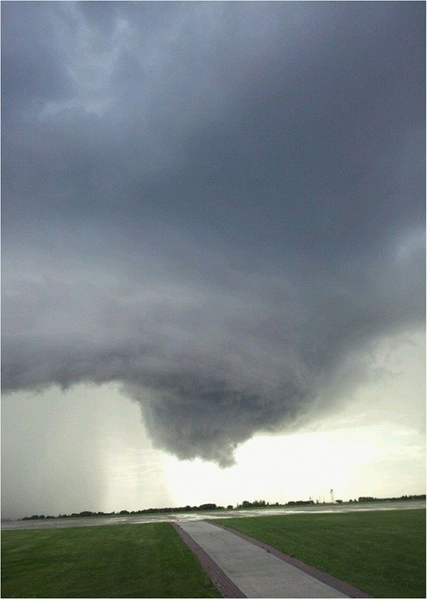

**[Insert Date and Time]**

Later that day, a large tornado is reported to have passed north of your area, devastating parts of the affected town. Local and state media report more than a dozen missing persons and several fatalities, in addition to significant damage to buildings, roads, and power lines. Local officials advise residents of your area to familiarize themselves with tornado safety practices.

The NWS issues a Tornado Watch for your town, including the area surrounding [insert institution name]. Other institutions in the surrounding area begin cancelling classes, athletic events, and social functions, and several of your student groups ask whether they should postpone their own scheduled events. Visiting professors and administrators who had been invited to an academic conference call to ask whether it is safe to travel to your institution. Faculty members and students express concern over the impact of power outages or systems damage on research equipment and perishable materials.

## Discussion Questions

### Operational Coordination

1. What plans, policies, and procedures does your institution have in place to prepare for a tornado?
2. Who in your organization is responsible for monitoring NWS alerts or would likely receive a bulletin from some other alerting authority?
3. What are your institution’s initial priorities after a Tornado Watch has been issued?
   1. What actions would your institution take at this point to ensure the safety and security of students, faculty, and staff?
4. How would your institution establish a command structure to coordinate your preparedness and mitigation efforts?
   1. Who are your key internal and external stakeholders, and how would your institution incorporate them into this command structure?
   2. How can your institution coordinate with private and public partners to ensure a whole-community preparedness effort?
5. What resource gaps could limit your institution’s ability to prepare for a tornado?
   1. What community resources and aid agreements could compensate for these resource gaps?
6. [Insert additional discussion questions as appropriate]

### Physical Protective Measures

1. What risks does a tornado pose to your institution’s key assets and systems (e.g., campus facilities, critical infrastructure)?
2. What resources and systems constitute your institution’s key operations and facilities?
3. How might a tornado damage those assets and systems?
4. What types of structural maintenance issues must you consider?
5. What plans and procedures (e.g., continuity of operations) does your institution have in place to mitigate the disruption of essential campus services?
6. Does your institution conduct regular tornado drills to familiarize students, faculty, and staff with safety procedures?
7. What steps can your institution take to protect your critical operations?
8. How do these steps account for on-campus and off-campus operations (e.g., critical infrastructure, online classes, labs)?
9. Are these steps documented in any institution plans, policies, or procedures?
10. What steps can your institution take to mitigate a temporary loss of critical operations?
11. Are these steps documented in any institution plans, policies, or procedures?
12. Does your institution have the necessary equipment to ensure continuity of operations in case of a temporary loss of critical facilities and infrastructure (e.g., back-up generators)?
    * 1. Is this equipment routinely tested?
13. [Insert additional discussion questions as appropriate]

### Health and Social Services & Mass Care Services

1. Are there identified locations where people should go in the event of a tornado?
   1. Do your students, faculty, and staff know how to find these locations?
   2. Have these locations been identified as the Best Available Refuge Area by a qualified architect or structural engineers?
   3. Are there any FEMA safe rooms or ICC 500 storm shelters at your institution?
   4. Are these locations equipped with emergency kits, including flashlights, first aid kits, dust masks, and whistles?
2. What plans, policies, and procedures does your institution have in place to ensure all students, faculty, and staff are safely sheltered in case of a Tornado Warning?
   1. How do these account for students with access and functional needs or students whose primary language may not be English?
3. [Insert additional discussion questions as appropriate]

### Public Information and Warning

1. What plans, policies, and procedures does your institution have in place to guide your internal and external communications strategies?
2. What internal and external stakeholders are you engaging at this time?
3. What information would you release to them?
4. How and when does your institution issue warnings, alerts, and other emergency messaging?
   1. How does your institution use pre-scripted or automated messaging that would expedite critical communications and public messaging?
   2. Does your jurisdiction have tornado sirens? If not, what other methods can you use to alert students, faculty, and staff of a Tornado Warning?
5. What individual, office, or department coordinates and delivers your institution’s public messaging?
6. How does your institution encourage students, faculty, and staff to take individual steps to mitigate the potential impacts of a tornado?
7. How will your institution use social media platforms in support of incident communications and public messaging?
8. [Insert additional discussion questions as appropriate]

# Module 2: Response

## Scenario (20 Minutes – 48 Hours)

**[Insert Date and Time]**

Figure 2: Tornado Making Landfall

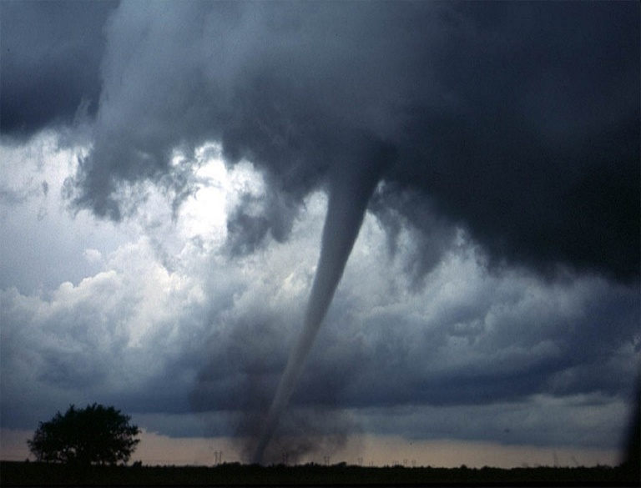

The NWS Issues a Tornado Warning for your area.

**[Insert Date and Time]**

Fifteen minutes later, a large tornado passes through the [insert institution name] campus, causing immediate power outages and structural damage to several academic and administrative buildings. The wind funnel also sweeps through parking lots, tearing cars apart and littering the campus with debris. Uprooted trees and airborne debris sever power lines, obstruct nearby roads, and cause additional structural damage to [insert institution name] buildings.

**[Insert Date and Time]**

In the immediate aftermath of the tornado, your institution receives multiple unconfirmed reports of students trapped beneath the rubble of damaged buildings. Many faculty members and students have suffered injuries that require treatment or hospitalization, and at least six people are currently unaccounted for, including two students with access and functional needs and one international student.

Large sections of the [insert academic building] roof have caved in, and portions of the [insert institution name] dining hall as well as several residential buildings have suffered significant structural damage. Large quantities of debris and several uprooted trees have blocked [insert nearby road], limiting access to your institution and delaying response operations. In addition to communication disruptions, downed power lines have resulted in widespread power outages throughout the area, including in most of your institution’s residential buildings.

**[Insert Date and Time]**

The two students with access and functional needs, the international student, and three members of staff, have not yet been located. Furthermore, your institution learns that a hospitalized student has died from injuries sustained during the tornado. After local media reports several more tornado-related fatalities within your area, your institution receives a flood of calls and emails from anxious families who have been unable to contact their children.

## Discussion Questions

### Operational Coordination

1. What are your institution’s initial priorities after a Tornado Warning is issued?
   1. What actions would your institution take at this point to ensure the safety and security of students, faculty, and staff?
2. What plans, policies, and procedures does your institution have in place to guide response efforts?
   1. What are your initial response priorities?
   2. Who is responsible for making this determination?
3. How would your institution establish and maintain an effective command structure to coordinate emergency response efforts?
   1. Who are the key decision-makers at this point?
   2. What are their specific roles and responsibilities?
4. How do key decision-makers collect information on damages and critical needs?
5. What resources are currently available?
   1. What plans, agreements, and contingency contracts are in place to address potential resource shortages?
6. Who are the key external stakeholders that would support response efforts?
   1. How would your institution coordinate and communicate with these stakeholders?
7. [Insert additional discussion questions as appropriate]

### Infrastructure Systems

1. How will your institution facilitate the speedy restoration of critical infrastructure systems and services?
2. How does your institution conduct damage assessments?
   1. Which infrastructure resources and systems would your institution prioritize during the response period?
3. How would your institution coordinate the restoration of critical infrastructure?
4. What stakeholders would you engage to facilitate this process?
5. What mechanisms does your institution implement to ensure continuity of operations during this response period?
6. How does your institution collect real-time updates on the status of its critical infrastructure?
7. [Insert additional discussion questions as appropriate]

### Mass Care Services

1. Who is responsible for tracking injuries, fatalities, and missing persons in the aftermath of a tornado?
2. What plans, policies, and procedures does your institution have in place to ensure the life safety and health of all students, faculty, and staff?
3. What are your response priorities in terms of providing mass care services?
   1. Does this strategy account for international students and students with access/functional needs?
4. What resource gaps could limit your institution’s ability to provide mass care services?
5. What community resources and aid agreements could compensate for these gaps?
6. What emergency housing plans, policies, and procedures does your institution have in place?
7. What resource gaps could limit your institution’s ability to meet your community’s emergency housing needs?
8. What community resources and aid agreements could compensate for those resource gaps?
9. [Insert additional discussion questions as appropriate]

### Public Information and Warning

1. How does your institution ensure consistent and coordinated public messaging throughout the initial response period?
   1. Who is responsible for delivering this public messaging?
   2. How does this messaging accommodate international students or students with access and functional needs?
2. How does your institution ensure timely and accurate situational updates for internal stakeholders throughout the response period?
   1. Who is responsible for delivering these updates?
   2. What sort of information is your institution releasing at this point?
3. Does your institution have a crisis communications plan or other means of communicating with all stakeholders in case of a breakdown of standard communications?
   1. How and when does your institution activate its crisis communications plan?
4. How does your institution notify families, key stakeholders, and the public of fatalities or serious injuries?
5. [Insert additional discussion questions as appropriate]

# Module 3: Recovery

## Scenario (48 Hours – 96 Hours)

**[Insert Date and Time]**

Figure 3: Tornado Damage

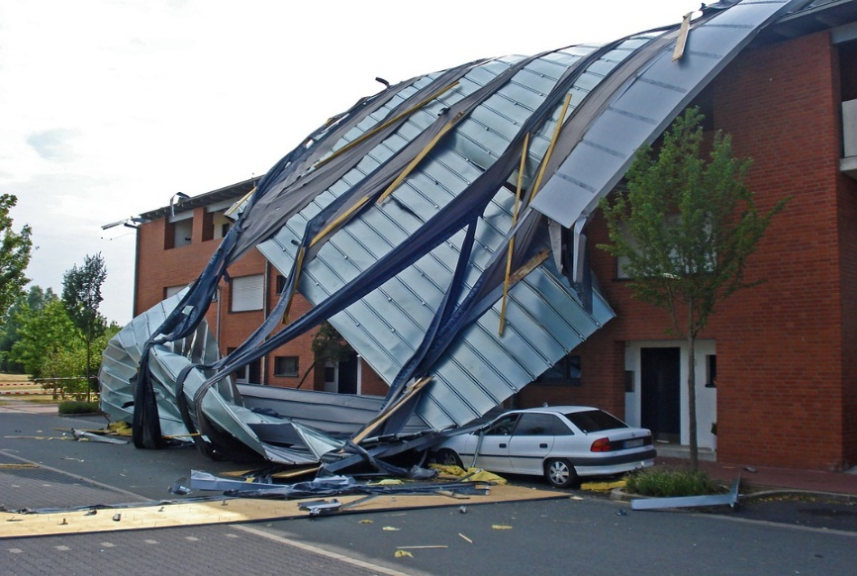

Roughly 48 hours later, a NWS storm survey team classifies the tornado as an EF3. Roadways leading to and from your institution remain partially clogged with debris, worsening traffic and causing several accidents. Power outages continue across your campus; additionally, multiple academic and administrative buildings require repairs and some student housing facilities remain uninhabitable.

All six missing persons have been recovered and hospitalized for injuries sustained during the tornado. There have been an additional [insert number] fatalities among faculty and staff, and [insert number] remain in critical condition.

**[Insert Date and Time]**

Over the course of the following week, students and families contact faculty and staff asking how class cancellations will impact their academic schedules as well as financial requirements and obligations. The families of international students also reach out to their embassies and consulates requesting information on how class cancellations could impact their children’s immigration statuses.

## Discussion Questions

### Operational Coordination

1. How does your institution coordinate the transition from response to short-term recovery efforts?
2. What plans, policies, and procedures guide your institution’s recovery process?
   1. Who is responsible for coordinating short- and long-term recovery efforts?
   2. What are your institution’s priorities for short-term recovery?
3. What resource gaps could limit your institution’s ability to meet these priorities?
   1. What community resources or aid agreements could compensate for those gaps?
   2. How can your institution coordinate with private and public partners to ensure a whole-community recovery effort?
4. What funding and assistance programs (e.g., FEMA grants) may be available to you and your institution in the aftermath of a significant tornado?
   1. Who is responsible for leading this effort?
5. [Insert additional discussion questions as appropriate]

### Infrastructure Systems

1. Which infrastructure systems would your institution prioritize during the recovery period?
2. How would your institution coordinate the complete restoration of critical infrastructure?
3. What stakeholders would you engage to facilitate this process?
4. How does your institution secure funds to support infrastructure restoration projects?
   1. What plans, policies, and procedures does your institution have in place to restore infrastructure systems that support and revitalize aspects of campus life, such as athletic programs and social events?
5. What mechanisms does your institution have in place to maintain continuity of operations throughout the recovery period?
   1. How does your institution build back safer and stronger so that future infrastructure systems are less susceptible to tornado damage?
6. [Insert additional discussion questions as appropriate]

### Mass Care Services & Health and Social Services

1. What plans, policies, and procedures does your institution have in place to return your campus to a healthy and safe environment?
   1. What are your recovery priorities in terms of providing mass care as well as health and social services (e.g., mental health services)?
   2. Does this strategy account for international students and students with access and functional needs?
2. What long-term housing plans, policies, and procedures does your institution have in place?
   1. How does your institution monitor the needs of students, faculty, and staff while they are housed in emergency shelters or housing facilities?
   2. Do you have mutual-aid agreements in place to provide long-term housing for students?
3. What resource gaps could limit your institution’s ability to meet your community’s long-term housing needs?
4. [Insert additional discussion questions as appropriate]

### Public Information and Warning

1. How does your institution ensure consistent, coordinated public messaging throughout the recovery period?
   1. How does your institution’s communications strategy transition from response-oriented to recovery-oriented messaging?
   2. How does this messaging accommodate international audiences and audiences with access and functional needs?
2. How does your institution provide internal stakeholders with timely updates concerning recovery efforts?
3. Who is responsible for monitoring and managing inquiries from affected students, faculty, staff, and alumni?
4. [Insert additional discussion questions as appropriate]

# Appendix A: Relevant Plans

[List any relevant plans, policies, or procedures to be tested during the exercise]

# Appendix B: Participating Organizations

[**Planner Note**: This section is in a table format. As you add/delete terms, you will need to do so by adding and/or deleting identified rows. To do this, highlight the identified row, right click, and choose add/delete as appropriate.]

|  |
| --- |
| Participating Organizations |
| [Insert Participating Organization] |
| [Insert Participating Organization] |
| [Insert Participating Organization] |
| [Insert Participating Organization] |
| [Insert Participating Organization] |
| [Insert Participating Organization] |
| [Insert Participating Organization] |

# Appendix C: Acronyms

[**Planner Note**: This section is in a table format. As you add/delete terms, you will need to do so by adding and/or deleting identified rows. To do this, highlight the identified row, right click, and choose add/delete as appropriate.]

| Acronym | Term |
| --- | --- |
| CR Program | Campus Resilience Program |
| DHS | Department of Homeland Security |
| EF | Enhanced Fujita Scale |
| EMS | Emergency Medical Services |
| FEMA | Federal Emergency Management Agency |
| HSEEP | Homeland Security Exercise and Evaluation Program |
| IHE | Institution of Higher Education |
| NED | National Exercise Division |
| NWS | National Weather Service |
| OAE | Office of Academic Engagement |
| SitMan | Situation Manual |
| TTX | Tabletop Exercise |
| [Acronym] | [Term] |
| [Acronym] | [Term] |

# Appendix D: Glossary

[**Planner Note**: This section is in a table format. As you add/delete terms, you will need to do so by adding and/or deleting identified rows. To do this, highlight the identified row, right click, and choose add/delete as appropriate.

This Glossary is not meant to be inclusive. Please tailor to your specific exercise and the needs of your participants. Once completed, be sure to delete this row, and any rows at the end that are not used.]

| Term | Definition |
| --- | --- |
| **Academic Recovery** | A component of the Continuity of Operations (COOP) annex identifying strategies to continue teaching after an incident. |
| **Access and Functional Needs** | A population whose members may have additional needs before, during, and after an incident in functional areas, including but not limited to: maintaining independence, communication, transportation, supervision, and medical care. Individuals in need of additional response assistance may include those who have disabilities, who are from diverse cultures, who have limited English proficiency, who are non-English-speaking, or who are transportation disadvantaged. |
| **After Action Report (AAR)** | A document intended to capture observations of an exercise and make recommendations for post-exercise improvements. The final AAR and Improvement Plan (IP) are printed and distributed jointly as a single AAR/IP following an exercise. |
| **Capabilities-Based Planning** | Determining capabilities suitable for a wide range of threats and hazards while working within a framework that necessitates prioritization and choice. Capabilities-based planning addresses uncertainty by analyzing a wide range of scenarios to identify required capabilities. |
| **Chain of Command** | The orderly line of authority within the ranks of the incident management organization |
| **Command Staff** | The staff who report directly to the Incident Commander, including the Public Information Officer, Safety Officer, Liaison Officer, and other positions as required. They may have an assistant or assistants as needed. |
| **Community Hazards** | Natural, technological, or human-caused hazards in the community that affect the school both directly, such as damage to the school building, and indirectly, such as making a road to the school impassable. |
| **Comprehensive Planning Guide (CPG) 101** | A guide designed to assist jurisdictions with developing plans. It promotes a common understanding of the fundamentals of planning and decision-making to help emergency planners examine a hazard and produce integrated, coordinated, and synchronized plans. |
| **Concept of Operations (CONOPS)** | A component of the basic plan that clarifies the school’s overall approach to an emergency (i.e., what should happen, when, and at whose direction) and identifies specialized response teams and/or unique resources needed to respond to an incident. |
| **Continuity of Operations (COOP)** | A functional annex providing procedures to follow in the wake of an incident where the normal operations of the school are severely disrupted. |
| **Critical Infrastructure** | Assets, systems, and networks, whether physical or virtual, so vital to the United States that the incapacitation or destruction of such assets, systems, or networks would have a debilitating impact on security, national economic security, national public health or safety, or any combination of those matters. |
| **Disaster** | An occurrence of a natural catastrophe, technological accident, or human-caused event that has resulted in severe property damage, deaths, and/or multiple injuries. |
| **Emergency** | Any incident, whether natural, technological, or human-caused, that requires responsive action to protect life or property. Under the Robert T. Stafford Disaster Relief and Emergency Assistance Act, an emergency means any occasion or instance for which in the determination of the President, Federal assistance is needed to supplement State and local efforts and capabilities to save lives and to protect property and public health and safety, or to lessen or avert the threat of a catastrophe in any part of the United States. |
| **Emergency Operations Center (EOC)** | The physical location at which the coordination of information and resources to support incident management (on-scene operations) activities normally takes place. An EOC may be a temporary facility or may be located in a more central or permanently established facility, perhaps at a higher level of organization within a jurisdiction. EOCs may be organized by major functional disciplines (e.g., fire, law enforcement, medical services), by jurisdiction (e.g., Federal, State, regional, tribal, city, county), or by some combination thereof. |
| **Emergency Operations Plan (EOP)** | An ongoing plan for responding to a wide variety of potential hazards. An EOP describes how people and property will be protected; details who is responsible for carrying out specific actions; identifies the personnel, equipment, facilities, supplies, and other resources available; and outlines how all actions will be coordinated. |
| **Emergency Support Functions (ESF)** | ESFs provide the structure for coordinating Federal interagency support for a Federal response to an incident. They are mechanisms for grouping functions most frequently used to provide Federal support to States and Federal-to-Federal support, both for declared disasters and emergencies under the Stafford Act and for non-Stafford Act incidents. |
| **Evacuation** | The organized, phased, and supervised withdrawal, dispersal, or removal of students, personnel, and visitors from dangerous or potentially dangerous areas. |
| **Family Reunification** | See Parent-Student Reunification. |
| **Hazard** | Something that is potentially dangerous or harmful, often the root cause of an unwanted outcome. |
| **Hazard Mitigation** | Any action taken to reduce or eliminate the long-term risk to human life and property from hazards. The term is sometimes used in a stricter sense to mean cost-effective measures to reduce the potential for damage to a facility or facilities from a disaster or incident. |
| **Homeland Security Exercise and Evaluation Program (HSEEP)** | A capabilities- and performance-based exercise program that provides standardized policy, doctrine, and terminology for the design, development, conduct, and evaluation of homeland security exercises. |
| **Human-caused Hazards** | Hazards that rise from deliberate, intentional human actions to threaten or harm the well-being of others. Examples include school violence, terrorist acts, or sabotage. |
| **Incident** | An occurrence, natural or human-caused, that requires a response to protect life or property. Incidents can, for example, include major disasters, emergencies, terrorist attacks, terrorist threats, civil unrest, wildland and urban fires, floods, hazardous materials spills, nuclear accidents, aircraft accidents, earthquakes, hurricanes, tornadoes, tropical storms, tsunamis, war-related disasters, public health and medical emergencies, and other occurrences requiring an emergency response. |
| **Incident Command System (ICS)** | A standardized on-scene emergency management construct specifically designed to provide an integrated organizational structure that reflects the complexity and demands of single or multiple incidents, without being hindered by jurisdictional boundaries. The Incident Command System is the combination of facilities, equipment, personnel, procedures, and communications operating within a common organizational structure, designed to aid in the management of resources during incidents. ICS is used for all kinds of emergencies and is applicable to small as well as large and complex incidents. ICS is used by various jurisdictions and functional agencies, both public and private, to organize field-level incident management operations. |
| **Incident Management** | The broad spectrum of activities and organizations providing effective and efficient operations, coordination, and support applied at all levels of government, utilizing both governmental and nongovernmental resources to plan for, respond to, and recover from an incident, regardless of cause, size, or complexity. |
| **Joint Information Center (JIC)** | A facility established to coordinate critical emergency information, crisis communications, and public affairs functions. The Joint Information Center is the central point of contact for all news media. The Public Information Officer may activate the JIC to better manage external communication. |
| **Joint Information System (JIS)** | A structure that integrates incident information and public affairs into a cohesive organization designed to provide consistent, coordinated, accurate, accessible, timely, and complete information during crisis or incident operations. The mission of the Joint Information System is to provide a structure and system for developing and delivering coordinated interagency messages; developing, recommending, and executing public information plans and strategies on behalf of the Incident Commander (IC); advising the IC concerning public affairs issues that could affect a response effort; and controlling rumors and inaccurate information that could undermine public confidence in the emergency response effort. |
| **Mass Care** | Actions taken to protect evacuees and other disaster victims from the effects of the disaster. Activities include providing temporary shelter, food, medical care, clothing, and other essential life support needs to the people who have been displaced because of a disaster or threatened disaster. |
| **Mitigation** | Includes activities to reduce the loss of life and property from natural and/or human-caused disasters by avoiding or lessening the impact of a disaster and providing value to the public by creating safer communities. Mitigation seeks to fix the cycle of disaster damage, reconstruction, and repeated damage. These activities or actions, in most cases, will have a long-term sustained effect. Examples: Structural changes to buildings, elevating utilities, bracing and locking chemical cabinets, properly mounting lighting fixtures, ceiling systems, cutting vegetation to reduce wildland fires, etc. |
| **Multi-jurisdictional Incident** | An incident requiring action from multiple agencies that each have jurisdiction to manage certain aspects of an incident. In the Incident Command System, these incidents are managed under Unified Command. |
| **National Disaster Recovery Framework (NDRF)** | The NDRF serves as a companion document to the National Response Framework, and is a guide to promote effective recovery, particularly for those incidents that are large-scale or catastrophic. |
| **National Incident Management System (NIMS)** | A set of principles that provides a systematic, proactive approach guiding government agencies at all levels, nongovernmental organizations, and the private sector to work seamlessly to prevent, protect against, respond to, recover from, and mitigate the effects of incidents, regardless of cause, size, location, or complexity, in order to reduce the loss of life or property and harm to the environment. |
| **National Infrastructure Protection Plan (NIPP)** | A coordinated approach used to establish national priorities, goals, and requirements to protect U.S. critical infrastructure and key resources. |
| **National Preparedness Goal (NPG)** | A document outlining the top priorities intended to synchronize pre-disaster planning, prevention, and mitigation activities throughout the nation, and to guide Federal, State, and local spending on equipment, training, planning, and exercises. The Goal provides an overarching vision, tools, and priorities to shape national preparedness. |
| **National Response Framework (NRF)** | A guide establishing a comprehensive, national, all-hazards approach to domestic incident response. It intends to capture specific authorities and best practices for managing incidents ranging from the serious but purely local, to large-scale terrorist attacks or catastrophic natural disasters. |
| **Natural Hazard** | Hazards related to weather patterns and/or physical characteristics of an area. Often natural hazards occur repeatedly in the same geographical locations. |
| **Parent-Student Reunification** | A common procedure implemented after an incident or emergency. A reunification area away from the incident is established for parents/guardians to reunite with their children. Parent-student reunification may be needed if the school is evacuated or closed as a result of a hazardous materials incident, fire, school violence, or other hazard. Related word: Relocation. |
| **Preparedness** | A continuous cycle of planning, organizing, training, equipping, exercising, evaluating, and taking corrective action in an effort to ensure effective coordination during incident response. Within the National Incident Management System (NIMS), preparedness focuses on the following elements: planning, procedures and protocols, training and exercises, personnel qualification and certification, and equipment certification. Examples: Conducting drills, preparing homework packages to allow continuity of learning if school closures are necessary, etc. |
| **Prevention** | Actions to avoid an incident or to intervene to stop an incident from occurring. Prevention involves actions to protect lives and property. Examples include: cyberbullying prevention, pandemic influenza sanitation measures, building access control procedures, security systems and cameras, etc. |
| **Psychological Healing** | A functional annex describing how schools will address medical and psychological issues resulting from traumatic incidents. |
| **Public Information** | Processes, procedures, and systems for communicating timely, accurate, and accessible information on an incident's cause, size, and current situation; resources committed; and other matters of general interest to the public, responders, and additional stakeholders (both directly affected and indirectly affected). |
| **Recovery** | Encompasses both short-term and long-term efforts for the rebuilding and revitalization of affected communities. Short-term recovery focuses on crisis counseling and restoration of lifelines such as water and electric supply, and critical facilities. Long-term recovery includes more permanent rebuilding. |
| **Relocation** | A common procedure implemented when the school building or environment surrounding is no longer safe. Students and staff are moved to an alternative facility where parents/guardians can reunite with children and/or teaching can continue. Related word: Parent-Student Reunification. |
| **Resilience** | Ability to adapt to changing conditions and withstand and rapidly recover from disruption due to emergencies. |
| **Response** | Activities that address the short-term, direct effects of an incident. Response includes immediate actions to save lives, protect property, and meet basic human needs. Response also includes the execution of emergency operations plans and of mitigation activities designed to limit the loss of life, personal injury, property damage, and other unfavorable outcomes. As indicated by the situation, response activities include applying intelligence and other information to lessen the effects or consequences of an incident; increased security operations; continuing investigations into the nature and source of the threat; ongoing public health and agricultural surveillance and testing processes; immunizations, isolation, or quarantine; and specific law enforcement operations aimed at preempting, interdicting, or disrupting illegal activity, and apprehending actual perpetrators and bringing them to justice. Examples: lockdown, shelter-in-place, evacuation of students, search and rescue operations, fire suppression, etc. |
| **Reverse Evacuation** | A common procedure implemented when conditions inside the building are safer than outside the building. |
| **Shelter-in-Place** | A common procedure implemented in the event of a chemical or radioactive release. Students and staff take immediate shelter, sealing up windows and doors, and turning off air ducts. |
| **Special Needs Population** | See Access and Functional Needs |
| **Specialized Procedures** | Standardized actions for specific populations or situations during an incident or emergency. Examples include special needs population, off-campus events, continuity of operations, mass care, and psychological healing. |
| **Technological Hazards** | These hazards originate from technological or industrial accidents, infrastructure failures, or certain human activities. These hazards cause the loss of life or injury, property damage, social and economic disruption, or environmental degradation, and often come with little to no warning. |
| **Terrorism** | As defined in the Homeland Security Act of 2002, activity that involves an act that is dangerous to human life or potentially destructive of critical infrastructure or key resources; is a violation of the criminal laws of the United States or of any State or other subdivision of the United States; and appears to be intended to intimidate or coerce a civilian population, to influence the policy of a government by intimidation or coercion, or to affect the conduct of a government by mass destruction, assassination, or kidnapping. |
| **Threat** | Natural, technological, or human-caused occurrence, individual, entity, or action that has or indicates the potential to harm life, information, operations, the environment, and/or property. |
| **Unified Command** | In incidents involving multiple jurisdictions, a single jurisdiction with multiagency involvement, or multiple jurisdictions with multiagency involvement, unified command allows agencies with different legal, geographic, and functional authorities and responsibilities to work together effectively without affecting individual agency authority, responsibility, or accountability. |
| **Warning** | The alerting of emergency response personnel and the public to the threat of extraordinary danger and the related effects that specific hazards may cause. A warning issued by the National Weather Service (e.g., severe storm warning, tornado warning, tropical storm warning) for a defined area indicates that the particular type of severe weather is imminent in that area. |
| **Watch** | Indication by the National Weather Service that in a defined area, conditions are favorable for the specified type of severe weather such as flash floods, severe thunderstorms, tornadoes, and tropical storms. |
| **[Term]** | [Term] |
| **[Term]** | [Term] |
| **[Term]** | [Term] |

*NOTE: The terms listed in this Glossary are gathered from FEMA sources, specifically Ready.gov and the FEMA’s Training Glossary.