FEMA Logo

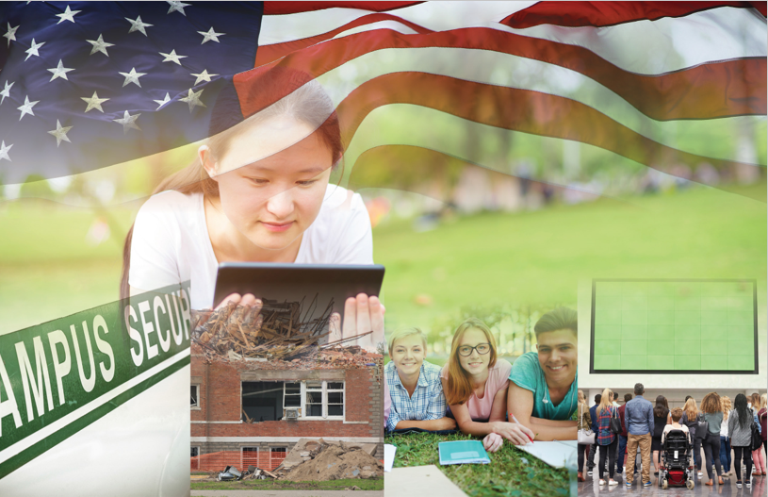

*Campus Resilience Program*

*Exercise Starter Kit*

**Active Shooter Tabletop Exercise**

Situation Manual

[Insert Date]

**Sponsor Logo**

# Handling Instructions

[**Planner Note:** The purpose of this Situation Manual is to provide a baseline exercise document that institutions of higher education can use to assess their emergency plans, policies, and procedures. The sample content contained in this document can be tailored as necessary to meet the desired goals and outcomes for the exercise by filling in all bracketed content that is highlighted in red. This document is to be used in tandem with the Active Shooter Tabletop Exercise Conduct Briefing and Facilitator Guide, therefore any changes made to this document will also need to be aligned with those documents.]

The title of this document is the *Active Shooter Tabletop Exercise (TTX) Situation Manual*. This document should be safeguarded, handled, transmitted, and stored in accordance with appropriate security directives. Reproduction of this document, in whole or in part, is prohibited without prior approval from the exercise planning team. This document has been marked as “FOR DISCUSSION PURPOSES ONLY.”

For more information on this exercise, please consult the following point of contact:

**[Lead Planner Name]**

[Position]

[Organization]

[Division within Organization]

[Phone]

[Email]

# Table of Contents

1. Handling Instructions i
2. Table of Contents ii
3. Agenda 1
4. Overview 2
5. General Information 3

Introduction 3

Overview 3

Objectives and Core Capabilities 3

Participant Roles and Responsibilities 4

Exercise Structure 4

Exercise Guidelines 5

Assumptions and Artificialities 5

1. Module 1: Initial Response 6

Background 6

Scenario 6

Discussion Questions 7

1. Module 2: Continued Response 9

Scenario 9

Discussion Questions 9

1. Module 3: Short-Term Recovery 11

Scenario 11

Discussion Questions 11

1. Appendix A: Relevant Plans A-1
2. Appendix B: Participating Organizations B-1
3. Appendix C: Acronyms C-1
4. Appendix D: Glossary D-1

# Agenda

**Active Shooter Tabletop Exercise**

**[Date]; [Time]**

**[Location of Exercise]**

[**Planner Note:** The agenda items and times listed below are general suggestions for the exercise breakdown. Activities and times may be adjusted based on an institution’s exercise scope, planned attendance, and duration.]

|  |  |
| --- | --- |
| [00:00 a.m.] | **[Welcome and Introductions] [Recommended Time: 5 Minutes]** |
| [00:00 a.m.] | **[Exercise Overview] [Recommended Time: 10 Minutes]** |
| [00:00 a.m.] | **Module 1: Initial Response [Recommended Time: 60 Minutes]** |
| [00:00 a.m.] | **Break [Recommended Time: 10 Minutes]** |
| [00:00 p.m.] | **Module 2: Continued Response [Recommended Time: 60 Minutes]** |
| [00:00 p.m.] | **Break [Recommended Time: 10 Minutes]** |
| [00:00 p.m.] | **Module 3: Short-Term Recovery [Recommended Time: 60 Minutes]** |
| [00:00 p.m.] | **[Exercise Hot Wash] [Recommended Time: 15 Minutes]** |
| [00:00 p.m.] | **[Closing Comments] [Recommended Time: 10 Minutes]** |

# Overview

|  |  |
| --- | --- |
| **Exercise Name** | Active Shooter Tabletop Exercise |
| **Exercise Date** | [Insert Date]; [Insert Start Time – End Time] |
| **Scope** | This exercise is a discussion-based tabletop exercise, planned for [insert exercise duration] at [insert exercise location]. Divided into three Modules, this exercise will examine response to and recovery from an active shooter scenario. |
| **Mission Areas** | Response and Recovery |
| **Objectives** | 1. **Operational Coordination:** Assess the ability to establish an effective command structure that integrates all critical stakeholders to ensure campus and community resources are used efficiently to respond to and recover from an active shooter incident. 2. **On-Scene Security, Protection, and Law Enforcement:** Evaluate the ability to provide a safe and secure environment for faculty, staff, and students, as well as first responders, during the response to an active shooter incident occurring on campus. 3. **Mass Care Services:** Examine processes and procedures to provide and coordinate mass care services to include life-sustaining and human services during the response to and recovery from an active shooter incident. 4. **Public Information and Warning:** Assess the ability to deliver coordinated, actionable, and timely information to critical partners and stakeholders when faced with an active shooter incident. 5. **Health and Social Services:** Examine the ability to protect, restore, and revitalize health and social services at your institution to promote the resilience, independence, health, and well-being of students, faculty, and staff. |
| **Scenario** | The exercise scenario will include an active shooter event resulting in a mass-casualty and mass-fatality incident on [insert your institution’s name] campus. |
| **Participating Groups/Departments** | * [Insert Participating Organization]   + [Insert Participating Sub-Organization] * [Insert Participating Organization]   + [Insert Participating Sub-Organization]   A full list of participating organizations is provided in **Appendix B.** |
| **Sponsoring Organization** | [Insert Sponsoring Organization(s)] |
| **Point of Contact** | [Insert Point of Contact Name], [Position], [Organization]  [Phone number], [Email] |

# General Information

## Introduction

This document serves as the Active Shooter Tabletop Exercise Situation Manual (SitMan). It includes the exercise goals and objectives, scenario details, as well as discussion questions for use during the exercise. In addition to aligning with the National Preparedness Goal, the content contained in this SitMan has been designed in accordance with Homeland Security Exercise and Evaluation Program (HSEEP) doctrine.

## Overview

The U.S. Department of Homeland Security (DHS), Office of Academic Engagement (OAE) is pleased to support the Active Shooter Tabletop Exercise as part of the broader Campus Resilience (CR) Program Exercise Starter Kits. This Exercise Starter Kit was made possible through collaboration and coordination with the Federal Emergency Management Agency (FEMA) National Exercise Division (NED).

The broader purpose of each Exercise Starter Kit offered through the CR Program is to support practitioners and senior leaders from the academic community in assessing emergency plans, policies, and procedures while also enhancing overall campus resilience. Specifically, this Exercise Starter Kit will provide the opportunity to examine response and recovery operations related to a campus mass shooting.

## Objectives and Core Capabilities

The following objectives in **Table 1** describe the expected outcomes for this exercise. The objectives are linked to core capabilities, which are distinct critical elements necessary to achieve the specific mission area(s).

Table 1: Exercise Objectives and Core Capabilities

|  |  |
| --- | --- |
| Exercise Objective | Core Capability |
| 1. Assess the ability to establish an effective command structure that integrates all critical stakeholders to ensure campus and community resources are used efficiently to respond to and recover from an active shooter incident. | * Operational Coordination |
| 1. Evaluate the ability to provide a safe and secure environment for faculty, staff, and students, as well as first responders, during the response to an active shooter incident occurring on campus. | * On-Scene Security, Protection, and Law Enforcement |
| 1. Examine processes and procedures to provide and coordinate mass care services to include life-sustaining and human services during the response to and recovery from an active shooter incident. | * Mass Care Services |
| 1. Assess the ability to deliver coordinated, actionable, and timely information to critical partners and stakeholders when faced with an active shooter incident. | * Public Information and Warning |
| 1. Examine the ability to protect, restore, and revitalize health and social services at your institution to promote the resilience, independence, health, and well-being of students, faculty, and staff. | * Health and Social Services |

# Participant Information and Guidance

## Participant Roles and Responsibilities

The term *participant* encompasses many groups of people, not just those playing in the exercise. Groups of participants involved in the exercise, and their respective roles and responsibilities, are detailed below.

### Facilitator(s)

The Facilitator will guide exercise play and is responsible for ensuring that participant discussions remain focused on the exercise objectives. They provide additional information and resolve questions as required. They are also responsible for making sure everyone is included in the conversation and has the opportunity to participate.

### Players

Players have an active role in discussing their preparedness, response, and recovery activities during the exercise. Players should discuss or initiate actions based on the simulated exercise scenario.

### Observers

Observers may visit or view selected segments of the exercise but do not actively engage in exercise discussions.

### Support Staff

The exercise support staff includes individuals who perform administrative and logistical support tasks during the exercise (e.g., registration, catering, etc.).

## Exercise Structure

The Active Shooter Tabletop Exercise will consist of three, [insert duration]-minute Modules that focus on response and recovery operations. Each Module will consist of two separate activities: a scenario overview and facilitated discussions. The exercise facilitator will first provide an overview of the scenario and will then engage participants in facilitated discussions around a set of questions. Discussions should focus on key actions, activities, and decisions that each player would perform given the specific scenario conditions. The three exercise Modules include:

* **Module 1** will focus on initial response operations during an active shooter incident
* **Module 2** will focus on continued response operations during an active shooter incident
* **Module 3** will focus on short-term recovery operations following an active shooter incident

The approximate duration of each exercise activity is noted in **Table 2** below.

[**Planner Note:** The timing of the items in Table 2 are general suggestions. Activities and times may be adjusted based on an institution’s exercise scope, planned attendance, and duration.]

Table 2: Module Structure

|  |  |  |  |
| --- | --- | --- | --- |
|  | Module 1 | Module 2 | Module 3 |
| **Total Minutes** | **[60 Minutes]** | **[60 Minutes]** | **[60 Minutes]** |
| **Scenario Updates** | **[5 Minutes]** | **[5 Minutes]** | **[5 Minutes]** |
| **Facilitated Discussions** | **[55 Minutes]** | **[55 Minutes]** | **[55 Minutes]** |

## Exercise Guidelines

This exercise will incorporate a scenario-based format guided by the event objectives. The Modules and associated discussion questions support achievement of the objectives by initiating discussions, facilitating decision-making, and assisting participants in the arrival of appropriate response outcomes. This approach allows the discussions to focus on situations within a moving timeline and for participants to contribute to the discussion from the perspective of their role in the scenario. The Facilitator will ensure that the scenario moves along at an appropriate pace and that all participants have an opportunity to contribute.

## Assumptions and Artificialities

### Assumptions

Assumptions are the implied factual foundation for the exercise and are assumed to be present before the exercise starts. The following assumptions apply to the exercise:

* Exercise players will use existing plans, policies, procedures, and resources to guide responses
* Participants may need to balance exercise play with real-world emergencies; real-world emergencies take priority
* [Insert any additional assumptions that may be relevant to the exercise]

### Artificialities

During this exercise, the following artificialities apply:

* The scenario is plausible, and events occur as they are presented
* There is no “hidden agenda” nor are there any trick questions
* The scenario assumes certain player actions as it moves through each phase; players should first discuss the actions stipulated by the scenario
* Players are welcome to engage in “what if” discussions of alternative scenario conditions
* [Insert any additional artificialities that may be relevant to the exercise]

# Module 1: Initial Response

## Background

It is the beginning of the fall semester midterm exams on your campus. Students are congregating in larger than average numbers in popular campus study locations such as libraries, student unions, and on-campus lounges. Upcoming midterm exams and the unseasonably cold and rainy weather mean that most of the on-campus student population is spending time inside.

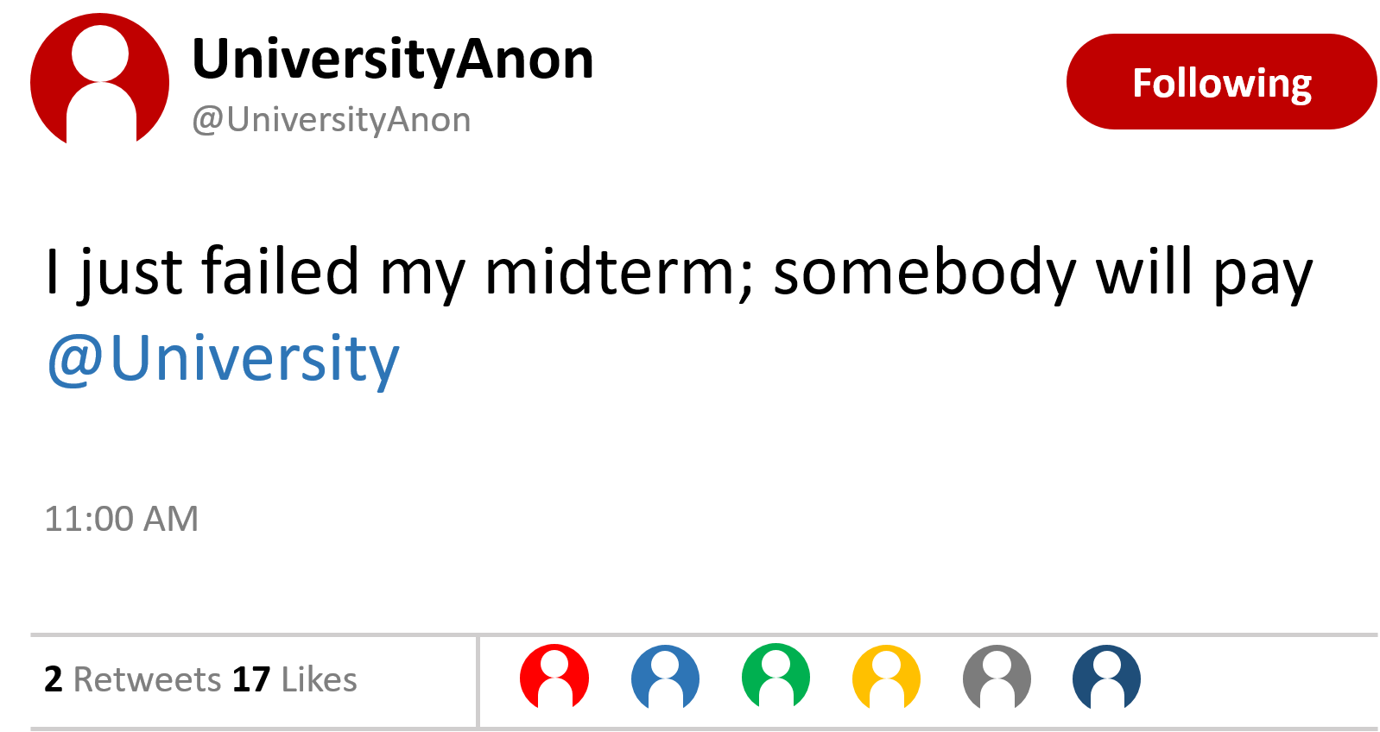

Figure : Simulated Social Media Threat

A student calls campus police and provides information about a social media post that says, “I just failed my midterm; somebody will pay”.

## Scenario

**[Insert Date and Time]**

Two hours later, an unidentified individual with two large duffle bags is seen entering the [insert building name], where multiple classes and exams are currently taking place. Soon after, loud “popping noises” and screams can be heard coming from a hallway on the first floor. The suspect enters classrooms one by one and begins firing a rifle indiscriminately at anyone he sees. Students in other classrooms, hearing the shots and screams, begin turning off lights, barricading doors, and hiding. Several students are seen fleeing the building and some of them are covered in blood and look like they are in shock. The gunman leaves the first floor through a stairwell and proceeds to walk up the stairs towards the second floor. The sound of popping noises and screaming continues sporadically.

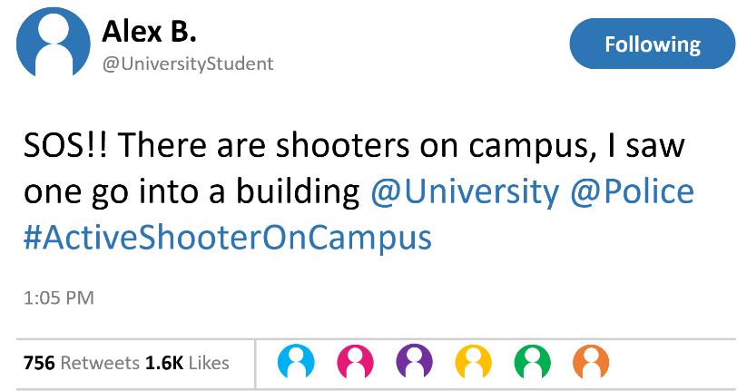

Figure : Simulated Social Media Post Regarding Active Shooter

Campus and local 9-1-1 operators receive calls from students both inside and outside of the building reporting popping noises, screaming, and flashes of light. Calls are frantic and do not provide a detailed understanding of the threat.

Additionally, posts on social media from students frantically reporting their experience both in and out of the [insert building name] building begin trending. Students in unaffected areas of campus begin to flee.

A campus police officer who is nearby hears gun shots and sees people frantically fleeing the building and leaving the surrounding area. He runs into the building and hears shots coming from an upper floor. He runs up the stairs and encounters the gunman in a second-floor hallway. The officer is hit and goes down outside one of the classrooms. The officer contacts dispatch and requests back up and medical assistance as he crawls to find cover.

Additional first responders from campus police, the local police department, fire-rescue, and emergency medical services (EMS) begin to arrive on scene.

## Discussion Questions

### Operational Coordination

1. What plans, policies, and procedures does your institution have in place to respond to an active shooter event?
2. What are your institution’s initial priorities?
3. How would your institution establish a command structure to coordinate your immediate response efforts?
   1. Does your institution have an established Emergency Operations Center? If so, how quickly can it be activated? If not, how would your institution coordinate with external stakeholders to track and manage the incident?
   2. Who are your key internal and external stakeholders and how would your institution incorporate them into this command structure?
   3. How can your institution coordinate with private and public partners to ensure a unified response effort?
4. What resource gaps could limit your institution’s ability to respond to an active shooter?
   1. What community resources and aid agreements could compensate for these resource gaps?
5. [Insert additional discussion questions as appropriate]

### On-Scene Security, Protection, and Law Enforcement

1. In terms of securing the scene, what are the immediate priorities?
   1. What plans, policies, or procedures are in place to maintain public safety during initial response efforts?
   2. What, if any, specialized teams would you utilize (e.g., rescue task force)?
   3. How would your institution coordinate with external stakeholders to conduct crowd management and maintain perimeter control?
2. Given the situation, what protective measures would you adopt at this point?
3. How would initial resource needs be prioritized in the event of a secondary attack?
4. How are external law enforcement assets integrated with campus assets?
   1. Have you trained or exercised with these law enforcement partners?
5. [Insert additional discussion questions as appropriate]

### Health and Social Services

1. What are your institution’s immediate health and social services priorities (e.g., evacuation, shelter-in-place, additional protective measures)?
2. What stakeholders would you begin to coordinate with?
   1. Who are your internal stakeholders?
   2. Who are your external stakeholders?
   3. Do you have existing partnerships with these stakeholders?
3. What critical decisions might need to be made at this point?
   1. Who at your institution is responsible for making and coordinating these decisions?
4. [Insert additional discussion questions as appropriate]

### 

### Public Information and Warning

1. What plans, policies, and procedures does your institution have in place to guide your internal and external communications strategies?
   1. Who are your internal and external stakeholders?
   2. What information should your institution release to them at this time?
2. How and when does your institution issue warnings, alerts, and other emergency messaging?
   1. How does your institution use pre-scripted or automated messaging that would expedite critical communications and public messaging?
3. What individual, office, or department coordinates and delivers your institution’s public messaging?
4. [Insert additional discussion questions as appropriate]

# Module 2: Continued Response

## Scenario

**[Insert Date and Time + 15 Minutes]**

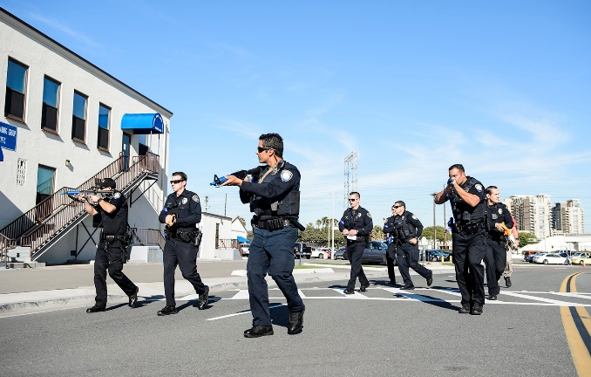

Figure : Law Enforcement Personnel

Campus and local law enforcement officials arrive on scene within minutes of the first 9-1-1 call from a student cell phone inside the building. Police quickly enter the building and ascend the stairs to the second floor where the wounded officer called in his request for backup. They begin a systematic search of the building for the gunman.

The shooter barricades himself inside the third-floor stairwell and hears police activity below. Once he sees armed officers on the third-floor landing, he fatally shoots himself. The police and EMS begin rescue operations.

**[Insert Date and Time + 1 Hour]**

National and local media outlets are beginning to provide coverage of the events, and reporting social media posts as the event unfolds. Conflicting information is being reported on various networks to include multiple suspects involved in a shooting rampage throughout multiple buildings across campus.

Upon hearing the news reports, parents begin inundating the campus with phone calls wanting to know if their children are safe and demanding information.

## Discussion Questions

### Operational Coordination

1. What plans, policies, and procedures does your institution have in place to guide response efforts at this point?
   1. How have your priorities shifted?
2. How would your institution maintain an effective command structure to coordinate emergency response efforts?
   1. Who are the key decision-makers at this point?
   2. What are their specific roles and responsibilities?
   3. Has your institution appropriately planned for integrating with an established Unified Command or a Joint Information Center? If not, what strategies would you use to gather critical incident-related information and updates?
3. How do key decision-makers collect information to assess the extent of the situation, to include injuries and fatalities?
4. What resources are currently available?
   1. What plans, agreements, and contingency contracts are in place to address potential resource shortages?
5. Who are the key external stakeholders that would support response efforts?
   1. How would your institution coordinate and communicate with these stakeholders?
6. [Insert additional discussion questions as appropriate]

### 

### On-Scene Security, Protection, and Law Enforcement

1. What response plans and protocols would your institution activate at this point?
   1. What stakeholders would be involved in managing and securing the scene?
2. Given the scenario, what protective measures would your institution adopt? Would your institution initiate an evacuation or a shelter-in-place?
3. In the event of an evacuation or a shelter-in-place, how does your institution ensure those with access and functional needs and those who do not speak English as a first language are able to follow correct procedures?
4. Do your campus security and law enforcement personnel have interoperable communications capabilities with external law enforcement personnel?
   1. Are there any personnel or resource challenges associated with this capability?
5. What strategies are in place at your institution to track deployed assets and account for deployed personnel?
   1. How do these strategies account for self-deploying personnel?
6. [Insert additional discussion questions as appropriate]

### Mass Care Services

1. What potential mass care challenges does this type of incident pose for emergency managers and law enforcement response personnel?
   1. What challenges does this incident pose, if any, for resource coordination efforts?
   2. Will the capacity of regional emergency medical services be sufficient and timely? What is the role of campus responders in supplementing these resources?
2. How would your institution address challenges of injured students both on-scene and those fleeing away from the scene?
   1. How will you coordinate with emergency responders and emergency care facilities to identify, locate, and transport injured or deceased persons?
3. Do you anticipate the need to establish a shelter at this point in the scenario?
   1. If so, how is this accomplished?
4. How will your institution account for students, faculty, staff, and campus guests in affected areas?
5. [Insert additional discussion questions as appropriate]

### Public Information and Warning

1. How does your institution ensure consistent, coordinated public messaging throughout this phase of response operations?
   1. Who is responsible for delivering this public messaging?
   2. How does this messaging accommodate international students and families as well as students with access and functional needs?
   3. How do your communication tools account for increased use during an incident?
   4. Should primary communication means become overwhelmed, what backup or alternative communication systems are in place?
2. How does your institution ensure timely and accurate situational updates for internal stakeholders throughout the response period?
   1. Who is responsible for delivering these updates?
   2. What sort of information is your institution releasing at this point?
3. How and when does your institution activate its crisis communications plan?
4. How does your institution notify families, key stakeholders, and the public of fatalities or serious injuries?
5. [Insert additional discussion questions as appropriate]

# Module 3: Short-Term Recovery

## Scenario

**[Insert Date and Time + 4 Hours]**

After a few hours, response personnel confirm that the threat has been neutralized. Law enforcement confirm that the gunman was indeed related to the credible threat of the tweet reported earlier in the day. Law enforcement also conduct building searches for possible accomplices and clear the campus of any additional suspects.

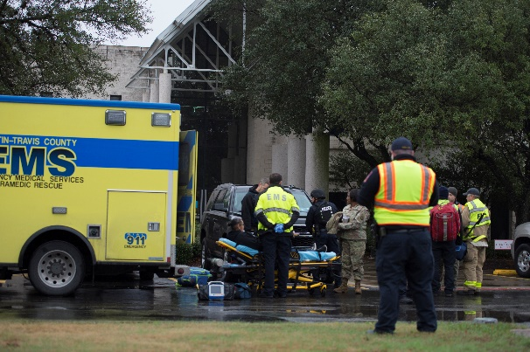

Figure : EMS Personnel

Individuals that sustained gunshot wounds and other injuries at the scene of the shooting have been transported to healthcare facilities and hospitals in the area. At this time, your institution is still compiling information on the number of wounded and how many patients each hospital has received. Additionally, your institution has transitioned from emergency response to fatality management operations for approximately [insert number] fatalities on several floors of the [insert building name] building. Your institution is working to confirm the identities of the deceased; although, at this time it is known that two international students were fatally shot. Furthermore, law enforcement was able to identify an individual who was fatally wounded as being a visitor on campus (not a student or faculty member).

By this time, both local and national media have acquired the threatening tweet from earlier in the day and are criticizing your institution for not acting quickly against this threat.

Students are active on social media posting that they are worried about returning to campus. Your institution is also getting calls from worried parents who are attempting to reach their children but have been unable to. They say that they have been monitoring the news but are still worried. Several parents have stated that they are driving to campus to find their children.

## Discussion Questions

### Operational Coordination

1. How does your institution coordinate the transition from response to short-term recovery efforts?
2. What plans, policies, and procedures guide your institution’s recovery process?
   1. Who is responsible for coordinating short- and long-term recovery efforts?
   2. What are your institution’s priorities for short-term recovery?
3. What resource gaps could limit your institution’s ability to meet these priorities?
   1. What community resources or aid agreements could compensate for those gaps?
   2. How can your institution coordinate with private and public partners to ensure a whole-community recovery effort?
4. [Insert additional discussion questions as appropriate]

### On-Scene Security, Protection, and Law Enforcement

1. What plans or procedures are in place to manage and secure the scene following the incident?
   1. How do these account for situations involving mass fatalities or casualties?
   2. At what point can a scene be considered safe or secure?
   3. Who is responsible for making this determination?
2. What additional stakeholders would be engaged to assist with these efforts?
3. What is your process for tracking the status and location of individuals who have been injured or fatally wounded?
4. What plans are in place for managing the presence of media and families on-site?
5. [Insert additional discussion questions as appropriate]

### Mass Care Services & Health and Social Services

1. What are your institution’s mass care and health and social services priorities transitioning into the recovery process?
   1. What type of information or services are you providing?
   2. What stakeholders would your institution engage to assist with this effort?
2. How does your institution coordinate, support, and track injuries and fatalities across the campus community?
   1. What external stakeholders would you be engaging to support with this effort?
   2. How does this account for families of international students?
   3. How has your institution coordinated with local/regional hospitals to address potential HIPPA- and FERPA-related limitations on patient status and shareable information?
   4. What is your institution’s victim assistance plan?
3. What plans or policies are in place to support affected populations?
   1. Do these plans provide guidance for supporting counseling and behavioral health needs of affected populations? In the short-term? In the long-term?
   2. What plans are in place for establishing a Reunification Center?
4. [Insert additional discussion questions as appropriate]

### Public Information and Warning

1. How does your institution ensure consistent, coordinated public messaging throughout the recovery period?
   1. How does your institution’s communications strategy transition from response-oriented to recovery-oriented messaging?
   2. How does this messaging accommodate international audiences and audiences with access and functional needs?
2. How does your institution provide internal stakeholders with timely updates concerning recovery efforts?
3. Who is responsible for monitoring and managing inquiries from affected students, faculty, staff, and alumni?
4. How would you maintain overall brand reputation for an incident involving an active shooter attack?
   1. How would potentially false or misleading information be handled?
   2. How would potentially sensitive information (e.g., victim names) be handled?
5. [Insert additional discussion questions as appropriate]

# Appendix A: Relevant Plans

[List any relevant plans, policies, or procedures to be tested during the exercise]

# Appendix B: Participating Organizations

[**Planner Note**: This section is in a table format. As you add/delete terms, you will need to do so by adding and/or deleting identified rows. To do this, highlight the identified row, right click, and choose add/delete as appropriate.]

|  |
| --- |
| Participating Organizations |
| [Insert Participating Organization] |
| [Insert Participating Organization] |
| [Insert Participating Organization] |
| [Insert Participating Organization] |
| [Insert Participating Organization] |
| [Insert Participating Organization] |
| [Insert Participating Organization] |

# Appendix C: Acronyms

[**Planner Note**: This section is in a table format. As you add/delete terms, you will need to do so by adding and/or deleting identified rows. To do this, highlight the identified row, right click, and choose add/delete as appropriate.]

| Acronym | Term |
| --- | --- |
| CR Program | Campus Resilience Program |
| DHS | Department of Homeland Security |
| EMS | Emergency Medical Services |
| FEMA | Federal Emergency Management Agency |
| HSEEP | Homeland Security Exercise and Evaluation Program |
| IHE | Institution of Higher Education |
| NED | National Exercise Division |
| OAE | Office of Academic Engagement |
| SitMan | Situation Manual |
| TTX | Tabletop Exercise |
| [Acronym] | [Term] |
| [Acronym] | [Term] |
| [Acronym] | [Term] |

# Appendix D: Glossary

[**Planner Note**: This section is in a table format. As you add/delete terms, you will need to do so by adding and/or deleting identified rows. To do this, highlight the identified row, right click, and choose add/delete as appropriate.

This Glossary is not meant to be inclusive. Please tailor to your specific exercise and the needs of your participants. Once completed, be sure to delete this row, and any rows at the end that are not used.]

| Term | Definition |
| --- | --- |
| **Academic Recovery** | A component of the Continuity of Operations (COOP) annex identifying strategies to continue teaching after an incident. |
| **Access and Functional Needs** | A population whose members may have additional needs before, during, and after an incident in functional areas, including but not limited to: maintaining independence, communication, transportation, supervision, and medical care. Individuals in need of additional response assistance may include those who have disabilities, who are from diverse cultures, who have limited English proficiency, who are non-English-speaking, or who are transportation disadvantaged. |
| **Active Shooter** | An individual actively engaged in killing or attempting to kill people in a conﬁned and populated area. In most cases, active shooters use firearms and there is no pattern or method to their selection of victims. |
| **After Action Report (AAR)** | A document intended to capture observations of an exercise and make recommendations for post-exercise improvements. The final AAR and Improvement Plan (IP) are printed and distributed jointly as a single AAR/IP following an exercise. |
| **Capabilities-Based Planning** | Determining capabilities suitable for a wide range of threats and hazards while working within a framework that necessitates prioritization and choice. Capabilities-based planning addresses uncertainty by analyzing a wide range of scenarios to identify required capabilities. |
| **Chain of Command** | The orderly line of authority within the ranks of the incident management organization |
| **Command Staff** | The staff who report directly to the Incident Commander, including the Public Information Officer, Safety Officer, Liaison Officer, and other positions as required. They may have an assistant or assistants as needed. |
| **Community Hazards** | Natural, technological, or human-caused hazards in the community that affect the school both directly, such as damage to the school building, and indirectly, such as making a road to the school impassable. |
| **Comprehensive Planning Guide (CPG) 101** | A guide designed to assist jurisdictions with developing plans. It promotes a common understanding of the fundamentals of planning and decision-making to help emergency planners examine a hazard and produce integrated, coordinated, and synchronized plans. |
| **Concept of Operations (CONOPS)** | A component of the basic plan that clarifies the school’s overall approach to an emergency (i.e., what should happen, when, and at whose direction) and identifies specialized response teams and/or unique resources needed to respond to an incident. |
| **Continuity of Operations (COOP)** | A functional annex providing procedures to follow in the wake of an incident where the normal operations of the school are severely disrupted. |
| **Critical Infrastructure** | Assets, systems, and networks, whether physical or virtual, so vital to the United States that the incapacitation or destruction of such assets, systems, or networks would have a debilitating impact on security, national economic security, national public health or safety, or any combination of those matters. |
| **Disaster** | An occurrence of a natural catastrophe, technological accident, or human-caused event that has resulted in severe property damage, deaths, and/or multiple injuries. |
| **Emergency** | Any incident, whether natural, technological, or human-caused, that requires responsive action to protect life or property. Under the Robert T. Stafford Disaster Relief and Emergency Assistance Act, an emergency means any occasion or instance for which in the determination of the President, Federal assistance is needed to supplement State and local efforts and capabilities to save lives and to protect property and public health and safety, or to lessen or avert the threat of a catastrophe in any part of the United States. |
| **Emergency Operations Center (EOC)** | The physical location at which the coordination of information and resources to support incident management (on-scene operations) activities normally takes place. An EOC may be a temporary facility or may be located in a more central or permanently established facility, perhaps at a higher level of organization within a jurisdiction. EOCs may be organized by major functional disciplines (e.g., fire, law enforcement, medical services), by jurisdiction (e.g., Federal, State, regional, tribal, city, county), or by some combination thereof. |
| **Emergency Operations Plan (EOP)** | An ongoing plan for responding to a wide variety of potential hazards. An EOP describes how people and property will be protected; details who is responsible for carrying out specific actions; identifies the personnel, equipment, facilities, supplies, and other resources available; and outlines how all actions will be coordinated. |
| **Emergency Support Functions (ESF)** | ESFs provide the structure for coordinating Federal interagency support for a Federal response to an incident. They are mechanisms for grouping functions most frequently used to provide Federal support to States and Federal-to-Federal support, both for declared disasters and emergencies under the Stafford Act and for non-Stafford Act incidents. |
| **Evacuation** | The organized, phased, and supervised withdrawal, dispersal, or removal of students, personnel, and visitors from dangerous or potentially dangerous areas. |
| **Family Reunification** | See Parent-Student Reunification. |
| **Hazard** | Something that is potentially dangerous or harmful, often the root cause of an unwanted outcome. |
| **Hazard Mitigation** | Any action taken to reduce or eliminate the long-term risk to human life and property from hazards. The term is sometimes used in a stricter sense to mean cost-effective measures to reduce the potential for damage to a facility or facilities from a disaster or incident. |
| **Homeland Security Exercise and Evaluation Program (HSEEP)** | A capabilities- and performance-based exercise program that provides standardized policy, doctrine, and terminology for the design, development, conduct, and evaluation of homeland security exercises. |
| **Human-caused Hazards** | Hazards that rise from deliberate, intentional human actions to threaten or harm the well-being of others. Examples include school violence, terrorist acts, or sabotage. |
| **Incident** | An occurrence, natural or human-caused, that requires a response to protect life or property. Incidents can, for example, include major disasters, emergencies, terrorist attacks, terrorist threats, civil unrest, wildland and urban fires, floods, hazardous materials spills, nuclear accidents, aircraft accidents, earthquakes, hurricanes, tornadoes, tropical storms, tsunamis, war-related disasters, public health and medical emergencies, and other occurrences requiring an emergency response. |
| **Incident Command System (ICS)** | A standardized on-scene emergency management construct specifically designed to provide an integrated organizational structure that reflects the complexity and demands of single or multiple incidents, without being hindered by jurisdictional boundaries. The Incident Command System is the combination of facilities, equipment, personnel, procedures, and communications operating within a common organizational structure, designed to aid in the management of resources during incidents. ICS is used for all kinds of emergencies and is applicable to small as well as large and complex incidents. ICS is used by various jurisdictions and functional agencies, both public and private, to organize field-level incident management operations. |
| **Incident Management** | The broad spectrum of activities and organizations providing effective and efficient operations, coordination, and support applied at all levels of government, utilizing both governmental and nongovernmental resources to plan for, respond to, and recover from an incident, regardless of cause, size, or complexity. |
| **Joint Information Center (JIC)** | A facility established to coordinate critical emergency information, crisis communications, and public affairs functions. The Joint Information Center is the central point of contact for all news media. The Public Information Officer may activate the JIC to better manage external communication. |
| **Joint Information System (JIS)** | A structure that integrates incident information and public affairs into a cohesive organization designed to provide consistent, coordinated, accurate, accessible, timely, and complete information during crisis or incident operations. The mission of the Joint Information System is to provide a structure and system for developing and delivering coordinated interagency messages; developing, recommending, and executing public information plans and strategies on behalf of the Incident Commander (IC); advising the IC concerning public affairs issues that could affect a response effort; and controlling rumors and inaccurate information that could undermine public confidence in the emergency response effort. |
| **Mass Care** | Actions taken to protect evacuees and other disaster victims from the effects of the disaster. Activities include providing temporary shelter, food, medical care, clothing, and other essential life support needs to the people who have been displaced because of a disaster or threatened disaster. |
| **Mitigation** | Includes activities to reduce the loss of life and property from natural and/or human-caused disasters by avoiding or lessening the impact of a disaster and providing value to the public by creating safer communities. Mitigation seeks to fix the cycle of disaster damage, reconstruction, and repeated damage. These activities or actions, in most cases, will have a long-term sustained effect. Examples: Structural changes to buildings, elevating utilities, bracing and locking chemical cabinets, properly mounting lighting fixtures, ceiling systems, cutting vegetation to reduce wildland fires, etc. |
| **Multi-jurisdictional Incident** | An incident requiring action from multiple agencies that each have jurisdiction to manage certain aspects of an incident. In the Incident Command System, these incidents are managed under Unified Command. |
| **National Disaster Recovery Framework (NDRF)** | The NDRF serves as a companion document to the National Response Framework, and is a guide to promote effective recovery, particularly for those incidents that are large-scale or catastrophic. |
| **National Incident Management System (NIMS)** | A set of principles that provides a systematic, proactive approach guiding government agencies at all levels, nongovernmental organizations, and the private sector to work seamlessly to prevent, protect against, respond to, recover from, and mitigate the effects of incidents, regardless of cause, size, location, or complexity, in order to reduce the loss of life or property and harm to the environment. |
| **National Infrastructure Protection Plan (NIPP)** | A coordinated approach used to establish national priorities, goals, and requirements to protect U.S. critical infrastructure and key resources. |
| **National Preparedness Goal (NPG)** | A document outlining the top priorities intended to synchronize pre-disaster planning, prevention, and mitigation activities throughout the nation, and to guide Federal, State, and local spending on equipment, training, planning, and exercises. The Goal provides an overarching vision, tools, and priorities to shape national preparedness. |
| **National Response Framework (NRF)** | A guide establishing a comprehensive, national, all-hazards approach to domestic incident response. It intends to capture specific authorities and best practices for managing incidents ranging from the serious but purely local, to large-scale terrorist attacks or catastrophic natural disasters. |
| **Natural Hazard** | Hazards related to weather patterns and/or physical characteristics of an area. Often natural hazards occur repeatedly in the same geographical locations. |
| **Parent-Student Reunification** | A common procedure implemented after an incident or emergency. A reunification area away from the incident is established for parents/guardians to reunite with their children. Parent-student reunification may be needed if the school is evacuated or closed as a result of a hazardous materials incident, fire, school violence, or other hazard. Related word: Relocation. |
| **Preparedness** | A continuous cycle of planning, organizing, training, equipping, exercising, evaluating, and taking corrective action in an effort to ensure effective coordination during incident response. Within the National Incident Management System (NIMS), preparedness focuses on the following elements: planning, procedures and protocols, training and exercises, personnel qualification and certification, and equipment certification. Examples: Conducting drills, preparing homework packages to allow continuity of learning if school closures are necessary, etc. |
| **Prevention** | Actions to avoid an incident or to intervene to stop an incident from occurring. Prevention involves actions to protect lives and property. Examples include: cyberbullying prevention, pandemic influenza sanitation measures, building access control procedures, security systems and cameras, etc. |
| **Psychological Healing** | A functional annex describing how schools will address medical and psychological issues resulting from traumatic incidents. |
| **Public Information** | Processes, procedures, and systems for communicating timely, accurate, and accessible information on an incident's cause, size, and current situation; resources committed; and other matters of general interest to the public, responders, and additional stakeholders (both directly affected and indirectly affected). |
| **Recovery** | Encompasses both short-term and long-term efforts for the rebuilding and revitalization of affected communities. Short-term recovery focuses on crisis counseling and restoration of lifelines such as water and electric supply, and critical facilities. Long-term recovery includes more permanent rebuilding. |
| **Relocation** | A common procedure implemented when the school building or environment surrounding is no longer safe. Students and staff are moved to an alternative facility where parents/guardians can reunite with children and/or teaching can continue. Related word: Parent-Student Reunification. |
| **Resilience** | Ability to adapt to changing conditions and withstand and rapidly recover from disruption due to emergencies. |
| **Response** | Activities that address the short-term, direct effects of an incident. Response includes immediate actions to save lives, protect property, and meet basic human needs. Response also includes the execution of emergency operations plans and of mitigation activities designed to limit the loss of life, personal injury, property damage, and other unfavorable outcomes. As indicated by the situation, response activities include applying intelligence and other information to lessen the effects or consequences of an incident; increased security operations; continuing investigations into the nature and source of the threat; ongoing public health and agricultural surveillance and testing processes; immunizations, isolation, or quarantine; and specific law enforcement operations aimed at preempting, interdicting, or disrupting illegal activity, and apprehending actual perpetrators and bringing them to justice. Examples: lockdown, shelter-in-place, evacuation of students, search and rescue operations, fire suppression, etc. |
| **Reverse Evacuation** | A common procedure implemented when conditions inside the building are safer than outside the building. |
| **Shelter-in-Place** | A common procedure implemented in the event of a chemical or radioactive release. Students and staff take immediate shelter, sealing up windows and doors, and turning off air ducts. |
| **Special Needs Population** | See Access and Functional Needs |
| **Specialized Procedures** | Standardized actions for specific populations or situations during an incident or emergency. Examples include special needs population, off-campus events, continuity of operations, mass care, and psychological healing. |
| **Technological Hazards** | These hazards originate from technological or industrial accidents, infrastructure failures, or certain human activities. These hazards cause the loss of life or injury, property damage, social and economic disruption, or environmental degradation, and often come with little to no warning. |
| **Terrorism** | As defined in the Homeland Security Act of 2002, activity that involves an act that is dangerous to human life or potentially destructive of critical infrastructure or key resources; is a violation of the criminal laws of the United States or of any State or other subdivision of the United States; and appears to be intended to intimidate or coerce a civilian population, to influence the policy of a government by intimidation or coercion, or to affect the conduct of a government by mass destruction, assassination, or kidnapping. |
| **Threat** | Natural, technological, or human-caused occurrence, individual, entity, or action that has or indicates the potential to harm life, information, operations, the environment, and/or property. |
| **Unified Command** | In incidents involving multiple jurisdictions, a single jurisdiction with multiagency involvement, or multiple jurisdictions with multiagency involvement, unified command allows agencies with different legal, geographic, and functional authorities and responsibilities to work together effectively without affecting individual agency authority, responsibility, or accountability. |
| **Warning** | The alerting of emergency response personnel and the public to the threat of extraordinary danger and the related effects that specific hazards may cause. A warning issued by the National Weather Service (e.g., severe storm warning, tornado warning, tropical storm warning) for a defined area indicates that the particular type of severe weather is imminent in that area. |
| **Watch** | Indication by the National Weather Service that in a defined area, conditions are favorable for the specified type of severe weather such as flash floods, severe thunderstorms, tornadoes, and tropical storms. |
| **[Term]** | [Term] |
| **[Term]** | [Term] |
| **[Term]** | [Term] |

*NOTE: The terms listed in this Glossary are gathered from FEMA sources, specifically Ready.gov and the FEMA’s Training Glossary.